EXECUTIVE MEETING

Date: Thursday,January 20, 2021
Time: 7:30 P.M.
Location: Online, via Zoom

1. Call to Order
The meeting was called to order at 7:35 pm by Steven Hewis who was chairing the meeting..

I) Present: Steve, Jane, Laura, Dan, Renata, Kamara, Marie, Sherrie, and Joanne
Paula-Ann will join after work

II)Regrets: Jeff, Gordon, Lisa

III) Adoption of Agenda.
Steven asked if everyone was was able to see the agenda posted on the forum. Everyone agreed to the agenda as presented.

a)Amendments
Jane stated that she wished to cover Reinvestment, but it was agreed that it could be brought up the Treasurer’s Report. Sherrie wished to clarify the naming of the 2021/2022 Season I) Valentines 2022 concert, suggesting that it be renamed as the Mid-winter Concert.

Motion to adopt the Agenda as amended
1st: Marie
2nd: Renata
Passed

2. November 18, 2021 meeting

I) Adoption of Minutes - November 18, 2021
Posted on the Forum

Motion to adopt the minutes as presented
1st: Marie
2nd: Jane
Passed

II) Business arising from the minutes -November 18, 2021
none stated

3) Reports

I) Treasurer’s Report
Jane did not write a Treasurer’s report this moth, but posted on the Forum a Statement of last year’s finances. She shared it via screen share.

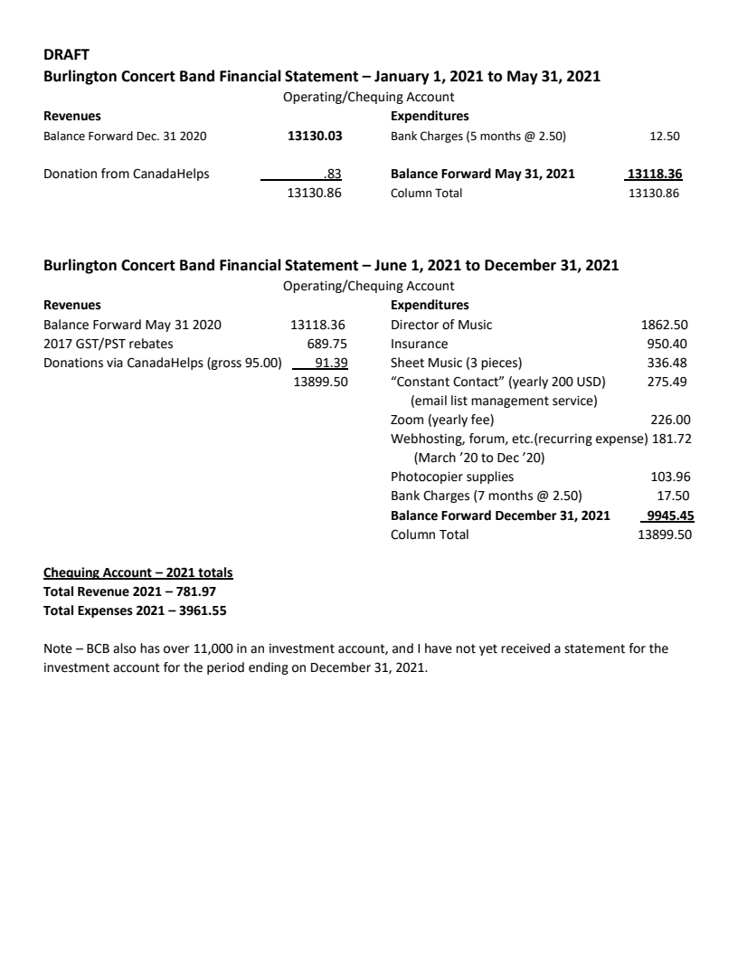
Jane commented that this was what we spent from June until December. In January, and the money we got. Otherwise all the bills have been paid, and Joanne has been properly reimbursed. Jane explained that for the band’s investments, one is currently is awaiting reinvestment and the other one matures in February. She would like a motion allowing her to proceed with reinvesting.

Motion to adopt the Treasurer’s Report as given
1st: Marie
2nd: Sherrie
Passed

Motion to invest the monies in the Band’s investment account into an one year GIC for February 2022.
1st: Jane
2nd: Marie
Passed

II) Director of Music

Joanne stated that she is willing to adjust the program if a mid-winter concert is held, The music for our portion of the joint concert has been finalized, Joanne is waiting for Laura to get back to her for the combined repetoire selection. She has heard suggestions, but nothing has been set in stone yet, and Joanne want to run by the executive at some point that we include a piece to honour the late Bobby Herriot, either one of his arrangements or “Highland Trumpeter”. It can be included in either the mid-winter concert, if held, or included in the summer concert repetoire.

II) Bylaw Review Committee - Gordon

Steven read the report from Gordon. The first meeting of the committee will be on Monday January 24, 2022 with another meeting in February to finalize recommendations to bebrought to the board. The board will receive them in March, and finalized them in April, which will allow them to be circulated to the membership in May, prior to the AGM in June. If anyone have any comments, they can be forwarded to Gordon.

4. New Business / Other Business (as per Forum Discussion)

I) Return to practice at the music center - January 31st, 2022

a) Scenario One : minimal restrictions (pre-Christmas) This scenario give the band FOUR (4) rehearsals before the March 6 concert
b) Scenario Two: enhanced restrictions (pre-Thanksgiving)
i) reduced capacity ii) instrument covers. This scenario gives the band FOUR (4) rehearsals before the March 6 concert, albeit these rehearsals would feature a reduced band and instrument cover constraints.
c) Scenario Three : NO return on January 31st This scenario gives the band at most THREE (3) rehearsals before the March 6 concert, assuming re-opening is only delayed 1 week

Steve wrote these before he heard from Rob and asked Joanne to comment on preparations. Joanne stated she would shelving Bugler’s Holiday and Stephan Foster as we have lost all of January for rehearsal, and they would not be performance ready. She suggested some music as replacement, if we were to go ahead with the concert. If we go with that concert, it would leave the band eight (8) rehearsals for the joint concert in May. Steve read Gordon’s comments in regards to the concert, suggesting restraint at this time. After a discussion between the members, it was felt that with the uncertainty with COVID-19 it would be prudent to cancel the spring concert, especially in light of our audience. Especially in light of the upcoming concerts in May (with DVO) and in June for the Butterfly Release.

Motion to Cancel the Mid-Winter Concert for 2022
1st: Sherrie
2nd: Jane
Passed

III) Logo and summer shirts
This item is to carried over to the next meeting.
5. 2021/2022 Season

I) Valentines 2022
Cancelled as per the previous motion

II) Spring 2022

Steven commented that he is ramping up his communications with DVO, who still wish to perform with us on Sunday, May 29th 2022 at 7:00 p.m. Once again Steven read a comment from Gordon. Gordon felt that the band should sell tickets as we have costs like advertising which must be covered, As well, this would allow for a larger donation to the charity which is chosen by the band. Jane reminded everyone that the majority of our tickets are sold via band family members and friends, next through the Burlington Post and the least sold through social media. A question was raised about DVO’s advertising strategy, which unfortunately could not be answered as Jeff was not present. Paula-Ann asked for clarification on the requirements from CWHM in regards for advertising the concert. Joanne commented that there are many retirement communities around Hamilton mountain which we could place posters or engage their social conveners. Laura was concerned about the financial implications from this concert, that we could actually lose money from this joint concert. Kamara suggested the band look at a possible group rate for seniors to increase the audience size. Dan commented that this concert could be approached as a promotion to say that the band is still around, and accept the possibility of this being a money loser. Jane suggested that we promote Canada Helps to the band members to help offset the concert, especially in lieu of not charging a membership fee for last 3 years. Steven
commented that DVO is donation based “pay-as-you-can”, which breaks down to $7 per person, when compared to BCB ticket pricing, which is $15. Dan felt that people would be willing to pay to see a concert in such a unique environment. Steve wrapped up the conversation by saying that there is nothing really can be voted on, but he he has gotten a lot of useful feedback and lots of preparation time for this concert.

III) Fundraising

Sherrie has three businesses which are willing to sponsor our Burlington-based concert. One was uncomfortable with e-transfers, which Jane said she check with the bank on the procedure. Steven said that it it doesn’t hurt to ask to get a sponsorship, and the package which he developed can be used by anyone.

IV) Moving Forward

Steve stated that he will to ask Jeff for follow-up from DVO’s perspective and get back to the Executive through the Forum. A discussion started about the location for the annual Christmas Concert and whether it is too son to start searching to a concert venue, Joanne stated that she has dates in November and December for concerts already set.... so no, it is not too early. Furthermore, Joanne stated that now would be the most opportune time as with COVID-19 restrictions coming to an end, that every group will be clamouring for performance venues. Sherrie asked whether or not St. Christopher’s must be used or if another church can be used, which she was told we can perform anywhere they would host us.. Steve stated that BPAC is definitely out of the question as they out of our budget, as at the minimum cost to book them would be $5000.00. Sherrie said that she will approach Port Nelson Church as we have cancelled out mid-winter concert there with the date of Friday, December 2th or 16th. Kamara asked about invited guests to increase audience interest, but it was felt that it is too early right now and that we should be cautious because COVID-19. Joanne said that she is willing to arrange a concert which features our own musicians. Steve stated, right now, that Sherrie should talk to the church and nail down a date for the concert.

6. Next meeting
It was agreed that the executive hold its next regular meeting via Zoom on February 17th at 7:30 pm. At that time, there will be a discussion on which night to hold the Executive meeting due to the fact that Joanne has other commitments on Thursday night.

7. Motion to Adjourn

Motion to adjourn at 9:14
1st: Sherrie
2nd: Paula-Ann
Passed

