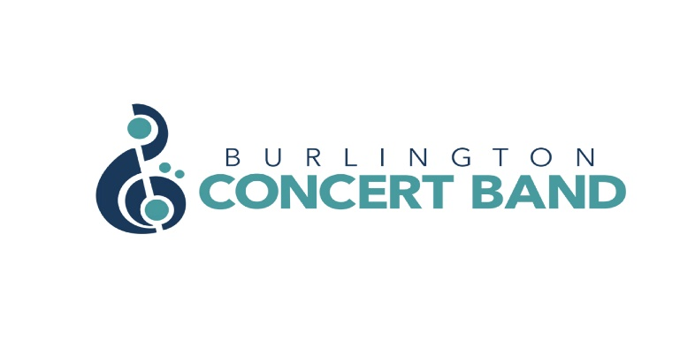
EXECUTIVE MEEING MINUTES
DATE: Wednesday February 15, 2023
TIME: 7:30 p.m.
LOCATION: 2027 Edinburgh Drive, Burlington

PRESENT: Dan Grieve, Steven Hewis, Laura Cristiano, Jeff Reynolds, Jane Clifton, Gordon Cameron, Kamara Hennessey, Kathryn Chirametli, Joanne Romanow

- Call to Order: 7:37p.m.
l) Regrets: Marie Limanni, Paula-Ann Simon, Lisa Liang

ll) Adoption of the Agenda/Amendments: Jeff motioned to adopt, Laura seconded. Vote: All in favour; carried.

- January 19, 2023 meeting:
l) Adoption of the Minutes from January 19, 2023 as a recording to be posted on the forum:
Gordon motioned to adopt, Jeff seconded. Vote: All in favour; carried.

ll) Business arising from the minutes: Nil report

- Reports:
l) Treasurer’s Report (on separate handout)
- Jane confirmed that she will step down as Treasurer after serving since 2016. She is prepared to stay on as a Member at Large.
- Steve reported that grants have put the budget for band expenses ahead by $3,500 even without revenue from the March concert.
- Gord motioned to accept the Treasurer’s Report, Jeff seconded. Vote: All in favour; carried.

ll) Director of Music Report:

Joanne reported:
- The poster should be ready by Tuesday, Feb 21st.
- The Band is ready for the concert on March 3rd.
- The program for May 5th is set. Program content includes: “Crown Imperial” to honour King Charles’s coronation, “The English Folk Songs Suites”, and lots of marches.
- Julian (Assistant Conductor) will conduct “Skyfall” in the May 5th concert.

Dan suggested the use of sectional practices. Joanne commented that there would be an issue with Covid exposure at other locations. The decision on this issue was set aside for review at a later date.

Dan motioned to adopt the report, Jane seconded. Vote: All in favour; carried.

4. New Business/Other Business:

l) Advertising streams:
- Dan suggested that the band advertise in the programs of other music groups.
- Jeff suggested speaking with local businesses about placing flyers in their store windows.
- Gord reported that nursing homes get information about BCB concerts but evening concerts are generally too late for them.

Actions: The Executive agreed that reciprocal advertising in music programs should be pursued. Jeff will proceed with this initiative by contacting the Dundas Valley Orchestra, where he is President, to arrange reciprocal advertising in band programs.

2) Summers shirts:
- Dan modelled a baseball cap, a toque, and Steve modelled a man’s t-shirt. All are in black with the band logo and are available in a women’s cut, and in tall sizes.
- Jeff suggested getting sizes small, medium, large and x-large for men.
- Joanne suggested getting some sample sizes for women to try on including small, medium, x-large, 1 & 2X.
- Joanne suggested the Butterfly release at the end of June as the launch for band members to start wearing the new uniform.
- Prices recommended by Dan: $30 for the shirt, $15 each for the cap and the toque. He will provide an online link to product line information.
- Jane motioned to accept the prices recommended by Dan. Gord seconded the motion. Vote: All in favour; carried.

3) Band collaboration:
- Collaboration with the Oakville Wind Orchestra is on hold.
- Steve will follow up with Jennifer Peace, Conductor of the New Horizons Band Burlington, about a joint concert

4) Executive Positions at the 2023 AGM:
- Kamara has created a list of band members interested in taking on responsibilities in the Executive
- Dan is interested in taking on the position of Treasurer
- Lisa would like to take on Memberships.
- Marie would like to continue as a Member at large
- Kamara has asked Kathryn Chirametli to act as Interim Secretary, taking over from Beth Brown
- There are 3 openings for Members at Large

5) Tents:
- Steve reported that rentals are more expensive than purchasing a tent. He is planning to buy a 10 x 30 foot tent for his wedding. If the Band wants the tent he could arrange to make a donation-in-kind.
- A tent could be used for outside events: Canada Day, Appleby Street Fest.
- Jeff bought a 10 X 10 gazebo tent for $1200. It was expensive but a sturdy choice.
- Further investigation and discussion will follow at a future meeting.

6) Concert and event schedule:
- Joanne talked about the program title for the May concert. English songs will be featured in the Spring concert.

- 2021/2022/2023 Season

l) MID-WINTER 2023

Subsection A – Information
- Date – March 3, 2023, 7:30 pm
- Location – Grace United Church
- Tickets - $15 each or $40 for 4
d) No notes were added to the program for each piece because it would make the program too long. A QR code has been added to the program.

Subsection B - Actions
a) Joanne agreed to help direct band members to their chairs. All members are listed by section in the program.
b) The sound check will be at 6:30 pm. Dan and Joanne will be at the Church by 5:30 pm.
c) The Sunday before the concert Gord will send out another eblast. 47% of the last email notices were opened, a good result.
d) Dan motioned that the KooGle Theatre Company receive an honorarium of $500, Gord seconded the motion. Vote: All in favour; carried.
e) Jeff motioned that a donation basket for Halton Learning Foundation be set out at the concert and that the Foundation receive 100 % of those donations. Gord seconded the motion. Vote: All in favour; carried.
f) Dan motioned that the Band accept the Compassion Society of Halton as a new charity partner. Jane seconded the motion. Vote: All in favour; carried.

ll) SPRING CONCERT 2023

Subsection A – Information
- Date - May 5, 2023
- Location – St. Christopher’s at cost of $600 for the space
- The encore will be “We’ll meet again.”
- Tickets - $60 for 4
- Donations to charity partners - donation baskets can be placed at the door. Food banks prefer cash donations.

Subsection B – Action Items
- The Executive agreed to adopt the program title: London Calling,
A Night of English Classics.
b) Al will confirm if the saxes will play during the intermission.

III) SOUND OF MUSIC

Subsection A - Information
- An application was made to join this Street Fest but all slots were booked. The Band can plan early to join in 2024.

lV) CANADA DAY/BURLINGTON 150

Subsection A – Information
a) Joanne reported that there are several local drummers who could be called to fill in at the concert if needed.

Subsection B – Action Items
a) The band will be polled to determine which members will be available for the concert.

V) SUMMER 2023

Subsection A – Information
- An application has been made to book the Burlington Band Shell
- Heritage Place, seniors’ residence, is a confirmed location
- Joanne will provide Steve with the name of the contact person for entertainment in the Village of Tansley Woods.

Vl) APPLEBY STREET FEST 2023

Subsection A – Information
a) Date – anticipated to be Sept. 17, 2023

Subsection B – Action Items
a) Lisa is the contact for this Street Fest. She will confirm the date and time (1:00 to 3:00?)

VII) FALL CONCERTS 2023

Subsection A - Information
- Jeff suggested the Burlington Art Gallery.
- Dan suggested a sing-along concert at the Seniors Centre.
- The idea of a Halloween concert for kids was set aside for now.

Subsection B - Actions
- Jeff will check on the rental fee charged by the Art Gallery.

VIII) CHRISTMAS CONCERT 2023
Subsection A – Information
- Date – Dec. 1, 2023
- Steve will follow up with Jennifer Peace about a joint concert with the New Horizons Band Burlington.

IX) FEBRUARY CONCERT 2024

Subsection A - Information
- A concert of French songs for children is proposed. The Band is likely to get lots of grants by planning a year ahead. Steve suggested approaching schools about a daytime field trip. The concert could include a demonstration of various instruments in the Band.

Subsection B - Actions
a) Steve will check on the cost to rent the hall at the Burlington Performing Arts Centre for this concert.

X) OTHER DISCUSSION

- The following concert themes are under consideration: Musical theatre with KooGle (May 2024), Jazz café (Feb. 2025), World cultures (May 2025)
- Steve met with Stephanie who is now responsible for general use of the Music Centre, the Teen Tour Band, and bookings . He explained the Band’s open policy of membership and the low fee to join, how we fund our concerts, and the history of the relationship between the BCB and Music Centre. The spaces the Band has rent-free are: the rehearsal hall on Mondays 8:00 p.m. to 10:00 p.m., the steel cage for the percussion equipment, and the office/library downstairs next to the washrooms.

- Next Meeting:
Thursday, March 16, 2023 at 7:30 p.m. Location is 3095 Woodland Park Drive.

- Motion to Adjourn the meeting: at 10:00 pm
Jeff motioned to adjourn the meeting at 10:00 p.m., Dan seconded. Vote: All in favour; carried.

Amended March 22, 2023

