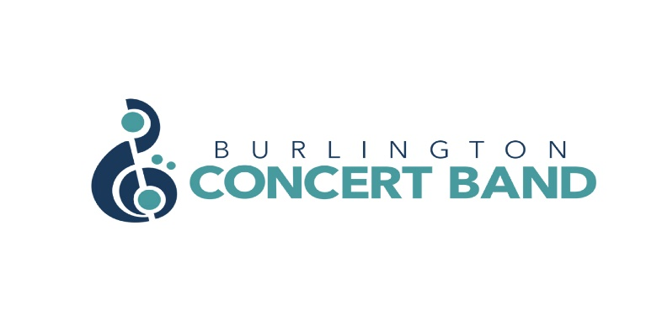
EXECUTIVE MEEING MINUTES
DATE: April 20, 2023
TIME: 7:30 p.m.
LOCATION: Zoom meeting

PRESENT: Jane Clifton, Kathryn Chirametli, Laura Cristiano, Dan Grieve (joined at 8:15 p.m.), Kamara Hennessey, Steven Hewis, Marie Limanni, Jeff Reynolds, Paula-Ann Simon.

- Call to Order: 7:34 p.m.
l) Regrets: Gordon Cameron, Lisa Liang, Joanne Romanow.

ll) Adoption of the Agenda/Amendments:
- Kamara noted that the meeting date should read April 20th, not April 19th, 2023.
- Marie moved to adopt the amended agenda. Jeff seconded the motion. Vote: All in favour;
carried.

- March 16, 2023 meeting:
l) Adoption of the Minutes from March 16, 2023 as a recording posted on Forum.
- Marie moved to adopt the Minutes as posted. Jane seconded the motion. Vote: All in favour; carried.

ll) Business arising from the minutes: Nil report

- Reports:
l) Treasurer’s Report (posted on Forum)
- Jane reported that all 2022 income tax receipts went out in February 2023.
- The Band’s G.I.C. is due for renewal. Responding to Kamara, Jane said she could probably arrange for an interest rate of 3 or 4%. Two signatures are required to renew the G.I.C. Steve will meet Jane on Monday, April 24th to reinvest the G.I.C.

- Jeff moved to accept the Treasurer’s Report. Paula-Ann seconded the motion. Vote: All in favour; carried.

ll) Director of Music Report:
- Joanne sent her report to the Executive by email. Her main concern is that the Band have only one concert during August. Steve said he would address this issue later in the meeting.

lll) Steve reported that Dan had ordered the new computer and would be picking it up very soon.

lV) Steve reported that shirt sales are going very well. Dan will place a bulk order on May 1st. Kamara asked if she could pay for her shirt when it arrived. Steve indicated that this would be ok as a spreadsheet is being used to keep track of orders and payments.

V) Steve reported on behalf of Lisa and Gord that the proof of the poster for the May 5th concert is being approved and should be available by Friday April 21st.

Jeff moved to accept all Reports as presented. Marie seconded the motion. Vote: All in favour; carried.

4. New Business/Other Business:

l) Website photography - no update

ll) Shirt sales - Discussed under section 3. lV)

lll) Band collaboration - BCB and the New Horizons Band Burlington will have a joint Christmas concert.

lV) Executive positions at 2023 AGM - Kamara has names for each position and will send the list to Steve for posting on Forum. Steve will check the Bylaws to confirm the lead time required for posting the names before the AGM.

V) The Executive discussed Paula’s proposal to add embellishments to the concert dress on May 5th. The consensus was that tartans were not in keeping with an English theme.

Jane moved to adopt the standard dress for the May 5th concert: black for women; black pants and jackets and white shirts for men. Marie seconded the motion. Vote: All in favour; carried.

- 2021/2022/2023 Season

l) SPRING CONCERT 2023 (May 5)

Subsection A – Information:

Subsection B – Action Items:
- Dan will organize transportation and Joanne will look after seating.
- Steve will ask Renate about arranging ticket takers.
- Kamara asked Steve to save a copy of the concert program for the Archives. He will arrange for the printing of approximately 150 – 175 programs.

ll) SOUND OF MUSIC 2023

Subsection A – Information:
- The Band’s application was not received but we could participate in the parade without compensation. The Executive decided to wait and apply again next year instead.

Subsection B – Action Items:

lII) SUMMER CONCERTS 2023

Subsection A – Information:
- The Bandshell is confirmed for August 27th.

Subsection B – Action Items:
- Steve will reach out to Heritage Place to confirm a concert date of August 14th. Several key players are away on August 21st but it could be a rain date if needed.
- Steve will reach out to Tansley to see if a July concert date can be arranged.

IV) APPLEBY STREETFEST 2023

Subsection A – Information:
- Date: September 17, 2023. Time: 1:00 – 3:00 p.m.
- Lisa is the lead on this event.

Subsection B – Action Items:

V) FALL CONCERT 2023

Subsection A – Information:
- The Broadway Bound Revival will be scheduled for Friday, October 20th. Time: 7:30 p.m.
Location: Grace United Church
- The Lerner and Loewe piece will be replaced by another, possibly by Oliver

Subsection B – Action Items:
- Christopher and Leslie, the soloists from KooGle indicated to Lisa that they were expecting a deposit of $200 for their work with the Band. Kamara recommended preparing a written performers’ contract for the October revival of Broadway Bound. Dan recommended a non-refundable deposit of $200 be conditional on an agreement to perform the concert on October 20, 2023.

- Jane moved that a performers’ contract be drawn up to cover the non-refundable $200 deposit to be paid now, tied to an additional $300 payment to be paid upon completion of the May 5th Spring Concert. Marie seconded the motion. Vote: All in favour; carried.

Vl) CHRISTMAS 2023

Subsection A – Information:
- Mercedes Benz has not been responsive to Jeff’s inquiries. An in-person visit is the next step. Kamara reported that her in-person visit in a previous year did not meet with a positive response.
- The joint Christmas concert with New Horizons Band Burlington will be on Friday, Dec. 1st.

Subsection B – Actions:
- Steve asked if there were other venues the Band could pursue. None were offered.
- Steve will reach out to Glad Tidings Church to see if they are interested in having the BCB perform there.
- The Band has been approved to participate in the Burlington Santa Claus Parade on Sunday, Dec. 3rd. There will be no compensation but the public exposure is desirable.

Vll) FEBRUARY 2024

Subsection A – Information:

Subsection B – Actions:
- Olde Tyme Classics, a concert selection geared for seniors, will be held in late February or early March.
- The Band is contractually obligated to go back to Grace United Church for this concert.

Vlll) SPRING 2024

Subsection A – Information:

Subsection B – Actions:
a) Steve will check to see if more KooGle theatre students can be involved in a Spring concert.

lX) Additional Comments:
- The French concert is planned for Fall 2024.
- Kamara suggested we get a new roll-up banner, with the Band’s new logo, to use at each concert. Steve agreed.
- Lisa will be asked about updating the sandwich board to conform with the new logo.

- Next Meeting: Thursday, May 18, 2023. Location: Jeff’s home at 24 Bloomsbury Court, Ancaster. Time: 7:30 p.m. Jeff will chair the meeting as Steve will not be able to attend the meeting.

- Motion to Adjourn the meeting at: 8:37 p.m. Marie moved to adjourn the meeting. Jeff seconded the motion. Vote: All in favour; carried.

