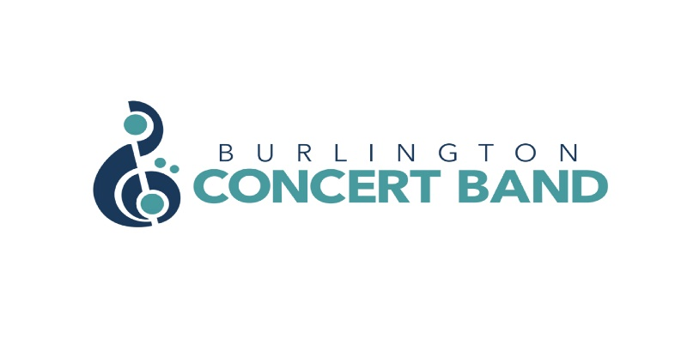
EXECUTIVE MEETING MINUTES
DATE: October 19, 2023
TIME: 7:30 p.m.
LOCATION: Zoom meeting

PRESENT: Gordon Cameron, Jane Clifton, Kathryn Chirametli, Laura Cristiano, Dan Grieve, Kamara Hennessey, Steven Hewis, Marie Limanni, Paula-Ann Simon, Jeff Reynolds.

REGRETS:

- Call to Order 7:32 p.m.
l) Regrets. Joanne, Lisa. Dan will arrive later in the Zoom meeting.

ll) Adoption of the Agenda/Amendments:

Gordon suggested we deal with the most important material on the agenda. However, Steven said many points are for information only.

Gordon moved to adopt the Agenda . Jeff seconded the motion. Vote: All in favour; carried.

- Minutes from September 27, 2023 meetings:
l) Adoption of the Minutes of September 27, 2023 as a recording to be posted on the forum.
Gordon moved to accept the Minutes of Sept . 27, 2023 as read. Jeff seconded the motion. Vote: All in favour; carried.

Dan moved to accept the Minutes of May 29, 2023. Paula-Ann seconded the motion. Vote: All in favour; carried.

ll) Business arising from the minutes: Kathryn will revise the Treasurers’ Report in the August 31, 2023 Meeting to read: “Dan has received the first G.S.T. rebate and the St. Stephen’s Endowment.”

- Reports:
l) Treasurer’s Report: Steven asked us to defer the report until Dan comes to the meeting.

ll) Director of Music Report: Joanne submitted to Steven a list of possible themes for the Spring 2024 Concert. See item 5. IV) for the list.

II) Mary Sobota has bequeathed her band music to BCB. 12 boxes and a 2- drawer filing cabinet have been accepted and will go to the library to be examined. Jane said that there might be some Clarinet Choir music to be returned to the original named owners. The Executive agreed that It would be good to pay tribute to Mary Sobota, possibly in a future concert program.

- New Business/Other Business:

l) Website photography:
Deanne Cameron was selected by the Executive to take photos at the next concert but she is not available to do them at this time. Professional photos will not be done for the October 20th concert. The Band will wait until winter or spring 2024 to use Deanne as our professional photographer. In the meantime, we can use photos supplied by band members.

II) Social media accounts/access/management – policy update
Marie would like to investigate further to determine the best practice around the use of passwords. Gordon will send Marie the list of the Band’s online sites and services. Steven said that the website and forum are different from these services as everyone is granted access using their own password. This discussion was tabled until further findings can be presented by Marie and Gordon.

III) Holiday gathering
Lisa has organized a band get together. She needs approval to spend up to $70 to pay for cake and icecream. The event will take place on Monday Dec. 11th, at 6:30 pm at Piper Arms (in the Walkers/Fairview area). There is a space limit of 25 people.

Jeff moved to approve funds to cover the party cost up to $70. Marie seconded the motion. Vote: All in favour; carried.

IV) DOM/ AC review

Joanne’s review by Steven and Paula-Ann was completed this past week. The next review is for the Assistant Conductor. Kamara asked if Joanne had mentioned problems with chatting or cell phone use during rehearsals. Steven suggested that the Executive talk to Joanne about cell phone use and chatting during rehearsals and get her reaction.

The Executive agreed that a general survey of the Conductor should be undertaken in May 2024. Jane will send Steven a list of questions that have been used previously to gather such information.

V) Concert and event schedule - Nil report

VI) Salvation Army Christmas Music
Steve is arranging to get these Christmas music books for about $300. There are about 200 songs included.

VII) Tent purchase
Gordon is still gathering information and will report back at a future meeting.

VIII) Portable wireless speaker/mic
The process is under way. More information is forthcoming.

IX) Website updates/ upgrade
Gordon will be updating the photos on the website.

X) Dundas Valley Orchestra
The Executive agrees to use DVO concert programs to advertise BCB concerts. BCB needs to provide the DVO with information and artwork to run in their programs for their February and May concerts.

5. 2023/2024 Season
- FALL 2023
Subsection A – Information:
- Gordon sent out Notations to remind band members of the October 20th concert details. Ticket sales are at 100. 150 is the max. Online sales go offline at midnight tonight. Renata. will know how many cash tickets can be sold.

Subsection B – Action Items:
- Marie noticed that the ad for the Band Shell concert on August 27, 2023 is still on our website and needs to be taken down.

II) CHRISTMAS 2023
Subsection A – Information:
- The location, (Holiday Inn), date, and time (Dec. 10, 1:00 p.m.) have been set and the music selected. Gordon will look after the poster and advertising. He is waiting for a picture of Hannah Bailey. The concert title is: Sleigh Ride and Snow Flakes. The ticket price is $20, or 4 for $60.

Subsection B – Action Items:
- A performance contract needs to be provided to Hannah Bailey.
- Steve will work with Joanne to arrange the music and rehearsals for Hannah Bailey.

III) WINTER 2024
Subsection A – Information:
- This concert will be on Sunday, March 3rd and preferably at Grace United Church. There is no cost because of our endowment agreement.
- Steven asked the Executive for their thoughts on splitting the March Concert into two 1-hr concerts, running back to back with different band members.
- Jeff thought we could consider the Holiday Inn as our main concert venue for Christmas because the capacity can accommodate our entire band.
- Dan suggested we ask band members to sign up for concerts on two different days rather than running concerts back to back.
- Jane suggested having one concert at Grace United, and one at a bigger venue.
- Marie worried that some sections would not have enough players to split between 2 concerts. Also, sections have players with different abilities.
- Jeff asked if the Executive has asked Joanne about having 2 concerts. Steven replied that she doesn’t like the idea of splitting the band into two, based on ability.

Subsection B – Action Items:
- Steve will take the idea of a sign up sheet and two concerts to Joanne to get her reaction.
- The Program Committee needs to set down the theme and music for this concert by the end of November. The theme could be Olde Tyme Classics from the 50s and 60s, or earlier. Information and art is needed to prepare publicity. Steve will look into the availability of a venue for the concert.
- Steve will post information on forum about the Executive having a strategic planning session during the Christmas break.
- The Holiday Inn works as a Christmas venue. It is affordable and can accommodate the entire band. Jeff asked if the Inn could handle refreshments. Steven will look back through his emails to see if the Inn addressed this question.
- Steven emphasized that the band needs to know by Nov. 6th who can participate as guests in our concert.

N.B. Marie left the meeting at 8:50 and Jeff at 8:55 p.m.

IV) SPRING 2024
Subsection A – Information:

- Joanne has a list of possible themes:
  - A Night at the Movies
  - A Night of Novelties
  - Leroy Anderson
  - Our Favourite Places
  - One Great Canada
  - Let’s Dance – We have enough in the library. We could easily do Let’s Dance I and Let’s Dance II
  - Andrew Lloyd Webber
  - Music of the British Isles
  - Band Masters
  - Zero to 60 – Music goes from slow to fast tempos.
  - Back in the Day – A History of Music
  - Award Winning Songs

- Gordon suggested we look at our choice of guests. Do they bring their own audiences?
- Paula-Ann asked about Vanier and if we could use francophone singers Paula-Ann offered to contact the aboriginal community in Hamilton to see if there are drumming groups that would be interested in being involved in one of our concerts.

Subsection B – Action Items:

- Dan suggested the theme of One Great Canada. We could include Aboriginal songs, and Canadian music theatre pieces by KooGle like Come From Away. The Executive thought this was a good theme to pursue further.
- Steven and Marie will ask KooGle about partnering with their students in a themed concert .

VI) SUMMER 2024
Subsection A – Information:

Subsection B – Action Items:
- Kamara will confirm that BCB will perform at Bereaved Families of Ontario, South Central Region’s “Walk of Remembrance and Butterfly Release” event.

VII) FALL 2024:
Subsection A – Information:
- The Band plans to play again at Appleby StreetFest.

Subsection B – Action Items:
- January 31, 2024 is the deadline to decide on the venue and set the date, time , theme and music outline

”.

- Next Meeting: Wednesday, November 15th, 2023 , 7:30 p.m. Location: Dan’s house. (2027 Eden Bird Drive, Burlington.)

- Motion to Adjourn: Gordon moved to adjourn the meeting at 9:05 p.m. Paula-Ann seconded the motion. Vote: All in favour; carried.

